**Lab 4**

Graph showing the model’s accuracy for each epsilon value

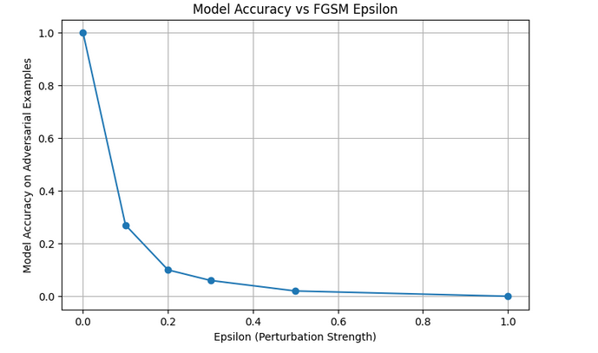

**Model accuracy before and after data poisoning:**

* Original Model Accuracy: 0.9811
* Poisoned Model Accuracy: 0.1135